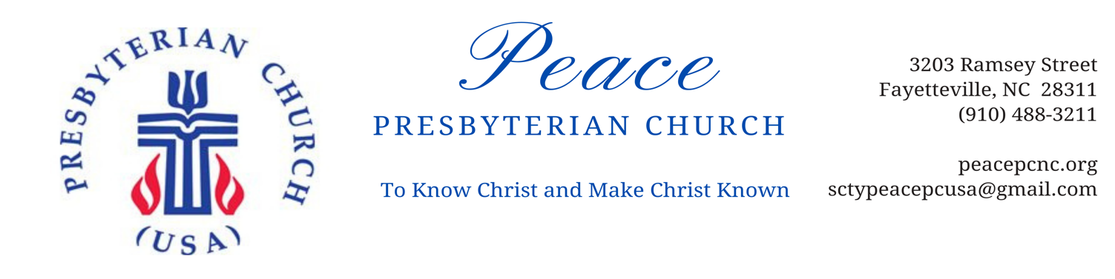
November 4, 2021
Dear Members and Friends of Peace Presbyterian Church,

Grace and peace to you in the name of our Lord and Savior, Jesus Christ! It is time to kick off the 2022 Stewardship Campaign. Our theme this year is “My Piece…Your Peace,” and we are inviting all of our members and friends to consider their partnership in ministry with Peace Presbyterian Church.

This year’s campaign begins on Sunday, November 7. Each member/family connected to our church will receive a stewardship packet and an invitation to join us in planning for ministry and mission in 2022. In the stewardship packet, you will find an Estimate of Giving form, a Time and Talent survey, and a blank puzzle piece for each member of your household. We ask that you consider and complete your work with these materials by Sunday, November 21, which is Dedication Sunday at Peace this year.

Estimate of Giving Form
It is important for budget planning that we have an accurate estimate of the financial resources that will be available for expenditure in 2022. You offer your piece of this puzzle when you complete the Estimate of Giving form. In doing so, you are not making a promise or pledge that is binding, or entering into any sort of a contract with us. Tithing is a spiritual discipline. We don’t tithe to meet the needs of the church budget, but because God, the Giver of all good gifts, invites us to give back a portion of our monetary resources for the sake of his mission in the world.

Time and Talent Survey
This is an opportunity to think about the time and talent you will share with Peace this coming year. Please consider the list of ministries and opportunities alongside what you know about yourself. What are your gifts and talents? How would you like to spend time with your church? Place checks on the lines that interest you.

Blank Puzzle Piece
This has been a season of learning just how big our church family is! Each person in your household is invited to create their own puzzle piece. Color or design it any way you would like and bring or send it back to the church by November 21. You are a piece of our Peace puzzle!

Stewardship Workshops
We will offer workshops during the week of November 15-20 to answer questions and talk through the materials in the packet (and provide art supplies for the puzzle pieces). See the enclosed information about the dates and times of these one hour workshops.

You are an important piece of the Peace puzzle, and we appreciate each way that you partner in ministry and mission with us.

Sincerely,

Elder Walt Swing, Treasurer Rev. Becky Durham, Pastor

